2021 Pilot of
GENERAL EDUCATION CERTIFICATE
Activity Book
TABLE OF
CONTENTS:
Activity 1: The Trilogy of happiness
Activity 2: Profile of 21st century learners
Activity 3: Personal and professional brick wall
Activity 4: The flourishing 21st century learner
Activity 5: Generational Gaps
Activity 6: E³ Competencies
Activity 7: Teachers yesterday and tomorrow
Activity 8: How can PBL start addressing the issues of 4IR and youth unemployment? Activity 9: How are you doing?
Activity 10: Professional Learning Communities (PLCs)
Activity 11: Intrinsic Motivation
Activity 12: Circle of Influence and Circle of Control
Activity 13: Commit to change - just do it!
GEC TRAINING: 2021
ACTIVITY BOOK
1. The Trilogy of Happiness
Activity 1.1 – The world and teaching today
1.1 The introduction has highlighted the following in my personal life:

In my professional life:
Activity 1.2 – The happiness trilogy
Answer the following questions/share the personal reflections:
1.2.1 How important is making your mark on the world?
1.2.2 Do you really think that a “worthwhile” life is so important in our pursuit of happiness?
3
GEC TRAINING: 2021
ACTIVITY BOOK
1.2.3 Personal reflection:
Underline your choice in each sentence:
I am / I am not yet a valued member of the teaching community because

I value / do not value the teaching community because

The teaching community is valued / is not valued because

I am happy / unhappy as a teacher and personally because
1.2.3 Create a visual to show how happy you are. If necessary, include obstacles to happiness in your visual diagram
4
GEC TRAINING: 2021
ACTIVITY BOOK
Activity 2: Profile of 21st century learners
2. In groups, link the body parts to 21st century teaching skills learners need to face a changing world, e.g. strong shoulders to bear the burdens of the changing world.
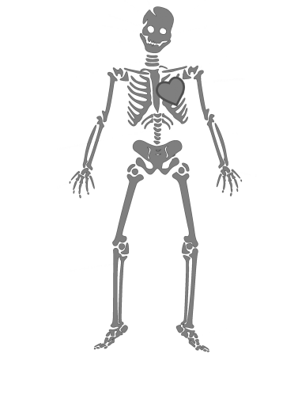5
GEC TRAINING: 2021
ACTIVITY BOOK
Activity 3: Personal and professional brick wall
Study the brick wall and in your own brick wall below insert obstacles that you experience personally in your own school, district, province.
6
GEC TRAINING: 2021
ACTIVITY BOOK
Activity 4: The Flourishing 21st Century Learner - who is s/he?
Study these pictures and think hard about what you wish for each learner at the end of Grade 9. What do they need to flourish?
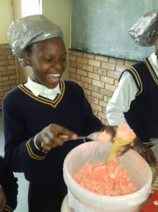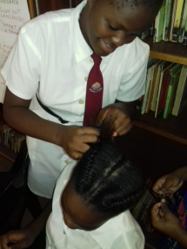Paste a picture of a learner you care for:
7
GEC TRAINING: 2021
ACTIVITY BOOK
Activity 5: Generational Gaps
5.1 Study the graphic below and in groups decide where each member of your team fits by writing their names in the correct category.
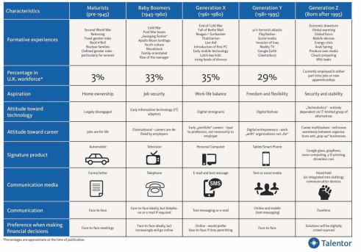5.2 Why is this information important for you and any teacher?
8
GEC TRAINING: 2021
ACTIVITY BOOK
Activity 6: E³ Competencies
Allocate a score to each of the E³ competencies in pairs (think of what learners need after school to flourish.)
(1 = Not at all important; 3 = somewhat important; 5 = critically important) Critical thinking Empathy
Creativity Citizenship
Reasoning Curiosity
Collaboration Resilience
Total =
Using the same rating scale, rate your own competencies as a teacher: Critical thinking Empathy
Creativity Citizenship
Reasoning Curiosity
Collaboration Resilience
Total =
9
GEC TRAINING: 2021
ACTIVITY BOOK
Activity 7: Teachers yesterday and tomorrow
7.1 In groups, complete this table:

Teaching success factors:
The past | The future
1
2
3
4
5
6

10
GEC TRAINING: 2021
ACTIVITY BOOK
Activity 8: How can PBL start addressing the issues of 4IR and youth unemployment? 8.1 How do you think PBL can start addressing the issues of 4IR and youth unemployment?
8.2 Why should we start addressing these issues?
11
GEC TRAINING: 2021
ACTIVITY BOOK
Activity 9: How are you doing? A simple PBL checklist.
PBL Facilitator | How I need to adapt / or not?
Design and plan
A learner problem arises and a lesson is created around it. She knows her curriculum and this will help her to link the problem to relevant CAPS information/ knowledge transfer.
Align to standards
Knows the CAPS and links her lesson to outcomes and expectations from the CAPS.
Build the culture
Understands that school culture plays a huge role in modeling appropriate and meaningful relationships.
Manage activities
The project is designed around practical real-life solutions. There is very little transmission teaching. Learners are given a task with clear instructions and the teacher observes learners and helps them when needed. She is a class and activity manager.
Scaffold student learning
She understands that all learners are different and in a variety of ways. She sees her role as that of supporter as each individual learner is helped to climb to the next level because of her one-on-one coaching.
Assess student learning
In her classroom, there are 3 types of assessment and each is treated differently and has a different purpose:
Baseline – where should we start?
Formative – How are we doing, every little step of the way?
Summative – How did we do when tested on a chunk of work?
Engage and coach
Her role is to pay attention to the needs of every learner and to offer them support, not via formal teaching, but by one-on-one coaching, especially as they work in groups.

12
GEC TRAINING: 2021
ACTIVITY BOOK
Activity 10: Professional Learning Communities (PLCs)
Complete the the following sentences:
10.1 Sitting in rows all the time and keeping to a fixed curriculum is sometimes good because .....
a bad idea because .....
10.2 Piaget said that knowledge is a consequence of experience.
Do you agree? Explain your answer. 4 lines
10.3 Give some advantages and some disadvantages of group work: 10.4 Groups should be fit for purpose. Explain:
13
GEC TRAINING: 2021
ACTIVITY BOOK
Activity 11: Intrinsic Motivation
In pairs, discuss and the complete the worksheet:
11.1 Why is it better for learners to be intrinsically motivated? 11.2 Are you and your colleagues always intrinsically motivated? Explain:
11.3 Would you agree that really good teachers are intrinsically motivated? Explain where the power of intrinsic motivation in a teacher lies.
14
GEC TRAINING: 2021
ACTIVITY BOOK
Activity 12 – Circle of Influence and Circle of Control
12.1 Study the following typical frustrations in a teacher's day and circle what you can control and underline what cannot be controlled.
1 | Children arrive at school hungry | 2 | Learners are undisciplined
3 | You lack the confidence to go to the principal to complain about a senior teacher who is giving you a hard time | 4 | ESKOM is load-shedding and you cannot plan your day because the schedules are not always accurate
5 | You are dissatisfied with the increase in the price of petrol | 6 | Some teachers do nothing - and you are overworked
7 | You do not understand the work you have to teach | 8 | You are often late for school and are always in trouble

12.2 Explain how the above activities will make you happier and more productive at work.
12.3 In the block below, insert one or two personal mantras in the next phase of your life.
MY PERSONAL MANTRA FOR SUCCESS:

12.4 Look through the following statements and reflect on your personal make-up by rating each statement on a scale from 1-4 where 1 = not at all and 4= very much so
RATING | RATING | RATING | RATING
 | If you succeed, I feel threatened |  | I don’t like to be challenged
 | Tell me I try hard |  | My effort and attitude determine everything
 | When I fail, I’m no good |  | Tell me I’m smart
 | I want to challenge myself |  | If you succeed, I’m inspired
 | When I’m frustrated, I persevere |  | My abilities determine everything
 | I’m either good at it, or I’m not |  | I can learn anything I want to
 | When I fail, I learn |  | When I’m frustrated, I give up

12.5 Underline the conclusion you have reached.
I show more qualities of a growth / fixed mindset
15
GEC TRAINING: 2021
ACTIVITY BOOK
Activity 13: Commit to change - just do it!
In pairs, discuss how you can commit to change by:
13.1 Saying what action you will take immediately:
13.2 Finding an inspiring quotation to embody your view of PBL as nation building:
13.3 What have you learned about mindset (the heart), skills (the hands) and knowledge (the head) to help you flourish as a PBL teacher?
16

