**THINKING MAPS APPLICATION TIPS**

When you are **Defining…**

|  |  |  |
| --- | --- | --- |
| **Key Words used** | **Questions asked** | **Applications** |
| Tell me everything you know about this topic, List, Define, Note the key points, Name all the types (of fractions, forces, habitats, plants, animals, qualities, points of interest) in this topic. Brainstorm, discuss. | What do you think this word means? What did we learn about this topic? What are the main issues raised in this video/book?  What are all the points you want to make (or learn) about this topic? What are all the ways of getting to this answer/number? | Formative Assessment of what students already know about a topic. This includes misconceptions, which you can be aware of.  A starting point to gather all ideas – firstly your own, and then perhaps more from peers, video or written material; or pre and post revision. |

**THE CIRCLE MAP**

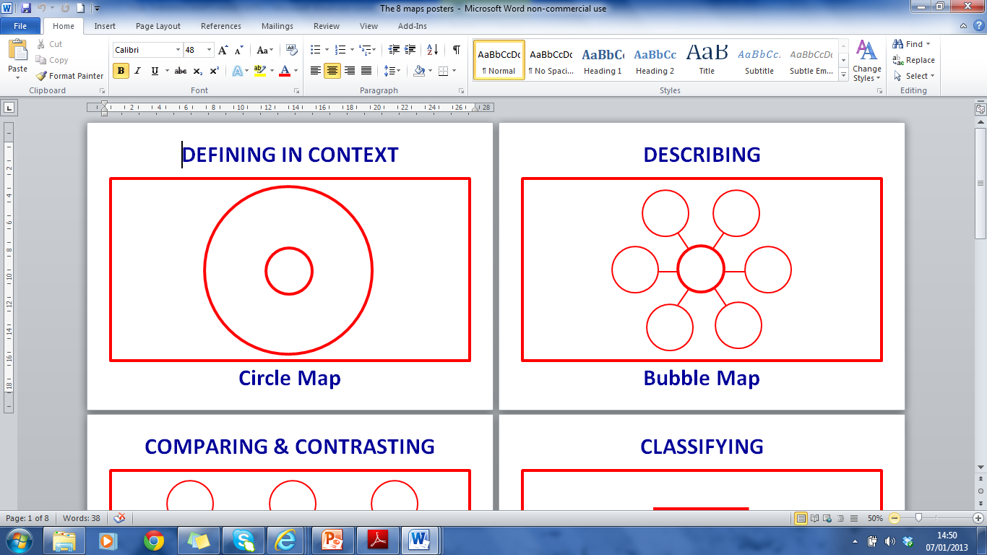**…then the Thinking Map to use is**

All information is gathered here

Note: You can use the Circle Map to measure growth in your thinking, such as checking and self-correcting information that is incorrect and adding new information in a different colour.

How you know goes in the outer rectangle: sources, experiences, influences, points of view

i.e. what you know

**Topic**

|  |  |  |
| --- | --- | --- |
| **Key Words used** | **Questions asked** | **Applications** |
| Describe feelings, attributes, characteristics, properties, adjectives, qualities. Use each of the 5 senses to explain how it feels, smells, sounds, tastes, looks. | How would you describe this in your own words? What is this really like? Which words would paint a vivid picture of it in your mind? | Generate rich and original adjectives before writing – to describe a setting, a character, or situation. Considering the properties of materials or visuals in Natural Science, Design and Technology or Art. |

When you are **Describing…**



**THE BUBBLE MAP**

**…then the Thinking Map to use is**

Adjective

Adjective

Adjective

Adjective

Adjective

**Subject**

Adjective

Note: The Bubble Map is for adjectives only.



It is not a Spider Diagram! (If you are looking for a Spider Diagram, either collect main ideas in a defining Circle Map or main headings in a classifying Tree Map, in which case you can also add sub-points under those headings).

When you are **Comparing and Contrasting…**

|  |  |  |
| --- | --- | --- |
| **Key Words used** | **Questions asked** | **Applications** |
| Compare/contrast, discuss similarities/differences, distinguish between, differentiate, what things/concepts have in common or not. | What are the similarities and differences between A and B?  What do they have in common?  What is unique to only one of them?  What distinguishing features help you identify them from each other? | Compare and contrast characters in a book/film, two shapes, methodologies, countries, time periods, formulae, technologies, types of plant or animal. Clarifying identifying properties that enhance understanding of forms, functions, applications and meanings. |

**THE DOUBLE BUBBLE MAP**

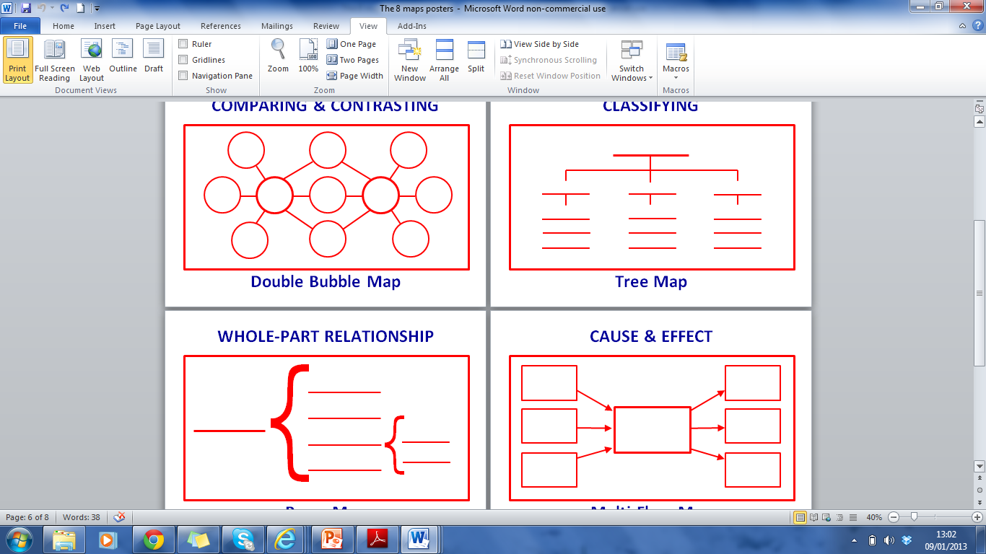**…then the Thinking Map to use is**

Difference

Difference

Similarity

Similarity

Difference

Difference

Difference

**Thing A**

**Thing B**

Difference

Difference

Note: Be careful to connect the lines to the rights places, based on the properties that link or differentiate A and B. Use the most striking or meaningful similarities and differences without mechanistically mirroring them (e.g. tall and short may be less distinguishing than that A is gangly and B is well-dressed). A and B can have different numbers of differences.

Difference

Difference

Difference

Difference

Similarity

Similarity

**B**

**A**

How you know

Similarity

Similarity

Difference

|  |  |  |
| --- | --- | --- |
| **Key Words used** | **Questions asked** | **Applications** |
| Classify, sort, group, categorise, give related detail, types of, kinds of, list and elaborate, taxonomy | How might you group the main ideas, supporting ideas and details in this topic? What are the key headings in this unit of work/project/talk/essay?  Can you sort all the information you have gathered into key concepts?  What important details do you want to add under each heading? | Making notes or summaries in any content area – students think about the category headings and the details of what they learn.  Categorising information from a Circle Map in preparation for writing about a topic or giving an oral presentation.  Collecting information under predetermined headings whilst reading a text. |

When you are **Classifying…**

**THE TREE MAP**

**…then the Thinking Map to use is**

Category Name

Note: Be careful to draw the Tree Map exactly as structured here.

Sub-Category

Sub-Category

Sub-Category

Detail

Detail

Detail

Detail

Detail

Detail

Detail

Detail

You can use the Tree Map to give students an overview of a subject, to see what is coming up and how units of work fit in. It is also extremely useful for revision.

Detail

When you are **Sequencing…**

|  |  |  |
| --- | --- | --- |
| **Key Words used** | **Questions asked** | **Applications** |
| Sequence, map the steps in this project, put in order, order, recount/re-tell, what happens next, cycles, patterns, processes, change, solve multi-step problems | What is the process/project you are sequencing? What is the step-by-step sequence of events in the process/project? What are the sub-stages? Is each step in the right order? | Mapping a sequenced step-by-step project in PBL. Life Cycles and processes in Natural Science/Social Science. Time lines in history.  Planning the sequence of a story for writing/recording the sequence of a story. Recording a thought process, such as in problem solving. |

**THE FLOW MAP**

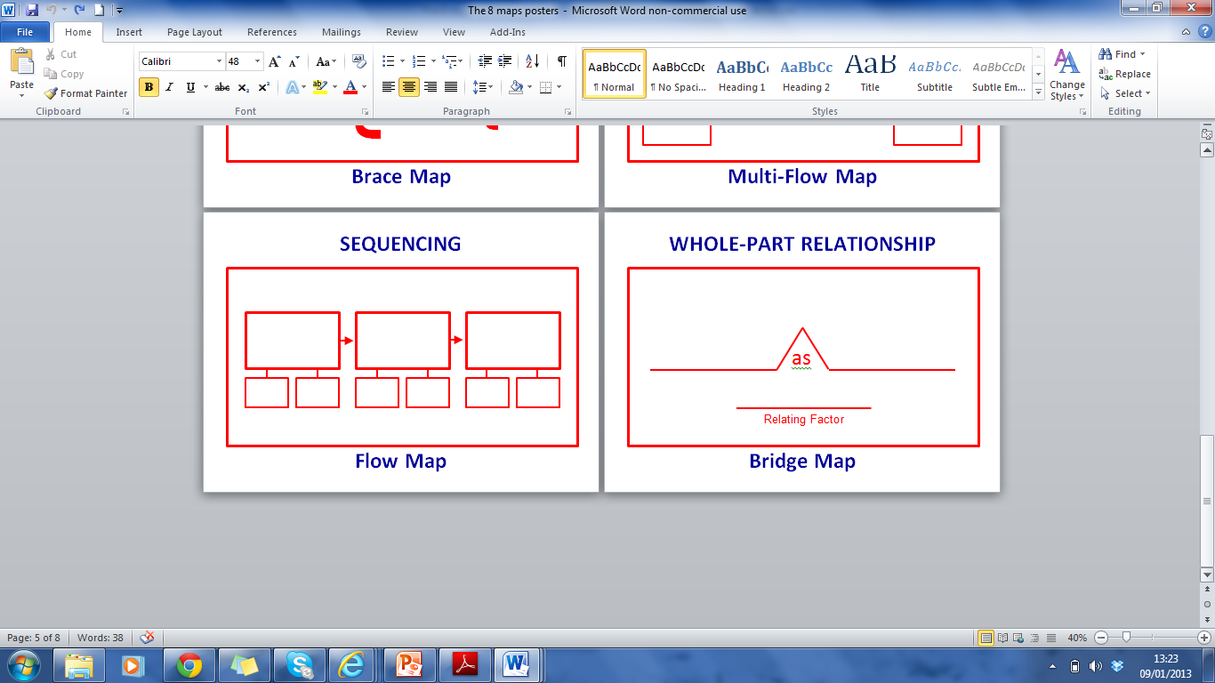**…then the Thinking Map to use is**

All information is gathered here

**Topic**

Note: Make sure that the Flow Map has arrows showing the order of events/stages. For life cycles it becomes a circle.

**Stage 1**

**Stage 2**

**Stage 3**

Stage 3

Stage 2

Stage 1

**Stage 1**

**Stage 2**

**Stage 3, etc**

How you know goes in the outer rectangle: sources, experiences, influences, points of view

i.e. what you know

General Note: Whilst it is vital to apply the Thinking Maps with the elements of each map exactly as they were designed, please don’t squeeze student thinking to the size or number of circles or blocks. Freehand maps that are corrected as they develop, capture more expansive thinking!

Sub-stages can be added if required (optional)

Sub-stages can be added beneath stages if relevant

Add any sub-sections that are important (optional)